Veterans Day Prayer Service
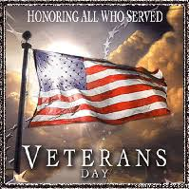
November 11, 2022, 9:15-9:45 a.m.

If you or a family member is a local veteran and would like to attend, please complete the form below and return to Colleen DeShayes in the front office, or email cdeshayes@ckrs.org. Middle school and student council students will be in attendance. Parents are welcome to the service along with their Veteran member and student. Please have your student alert their teacher if they are attending with their guest. Please see https://ctkhaddonfield.org/ for live viewing of the service
Please return this confirmation of participation ASAP. Please arrive 10 minutes early to be seated in the church
Veteran’s Name______________________________________
Phone #______________ Email__________________________
CKRS family name _____________________ Student’s class________
Brief notes on type of service and rank ______________________________________________________
Number of members attending including CKRS student _____

